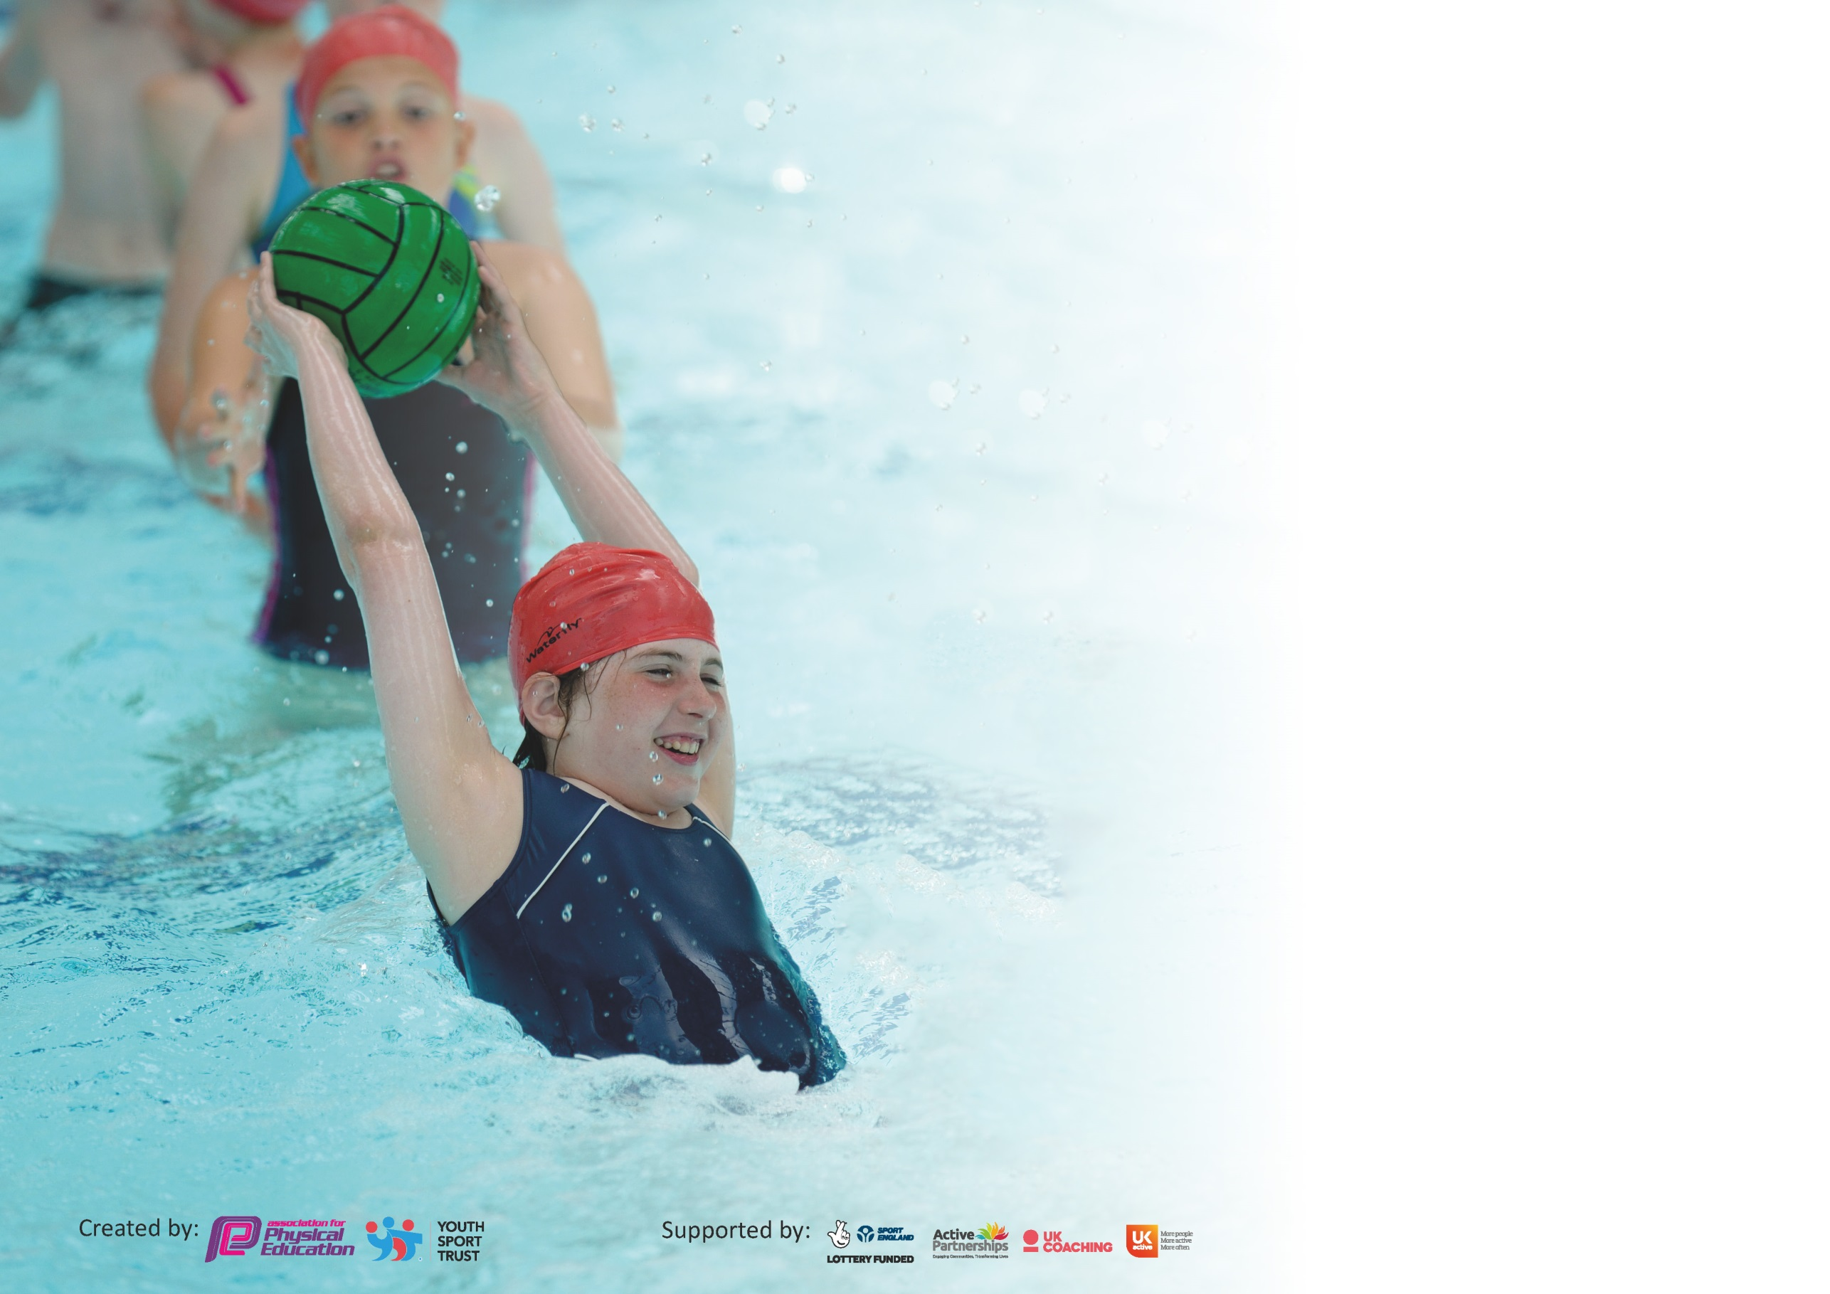

It is important that your grant is used effectively and based on school need. The Education Inspection Framework (Ofsted 2019 p64) makes clear there will be a focus on ‘whether leaders and those responsible for governors all understand their respective roles and perform these in a way that enhances the effectiveness of the school’.

Under the Quality of Education criteria (p41) inspectors consider the extent to which schools can articulate their curriculum (INTENT), construct their curriculum (IMPLEMENTATION) and demonstrate the outcomes which result (IMPACT).

To assist schools with common transferable language this template has been developed to utilise the same three headings which should make your plans easily transferable between working documents.

Schools must use the funding to make additional and sustainable improvements to the quality of Physical Education, School Sport and Physical Activity (PESSPA) they offer. This means that you should
use the Primary PE and Sport Premium to:

- Develop or add to the PESSPA activities that your school already offer
- Build capacity and capability within the school to ensure that improvements made now will benefit pupils joining the school in future years

Please visit gov.uk for the revised DfE guidance including the 5 key indicators across which schools should demonstrate an improvement. This document will help you to review your provision and to report your spend. DfE encourages schools to use this template as an effective way of meeting the reporting requirements of the Primary PE and Sport Premium.

We recommend you start by reflecting on the impact of current provision and reviewing the previous spend.

Schools are required to publish details of how they spend this funding as well as on the impact it has on pupils’ PE and sport participation and attainment by the end of the summer term or by 31st July 2020 at the latest.

We recommend regularly updating the table and publishing it on your website throughout the year. This evidences your ongoing self-evaluation of how you are using the funding to secure maximum, sustainable impact. Final copy must be posted on your website by the end of the academic year and no later than the 31st July 2020. To see an example of how to complete the table please click HERE.

Support for review and reflection - considering the 5 key indicators from DfE, what development needs are a priority for your setting and your pupils now and why? Use the space below to reflect on previous spend and key achievements and areas for development.

Key achievements to date until July 2020: | Areas for further improvement and baseline evidence of need:
- Platinum School Games Mark  - Sports awards given in our cluster for recognition of commitment to PE during pandemic and before.  - 38 different local sporting activities have been attended with Netball progressing to County Finals.  - 66% of KS2 have attended a sports club  - 64% KS2 have represented the school at a competition or festival  SADO; 2nd place in Netball league , Small school Indoor athletics 1st , Year 3/4/ Aquasplash 1st year 5/6, Aquasplash 3rd, Boys Gymnastics 2nd | - Further development of the curriculum to include Active Maths within most classrooms in order to improve teaching and learning  - Continue to target activities for the least active children such as change4life clubs and inter-school festivals  - Maintain the Platinum School Games Mark 2020/21

Meeting national curriculum requirements for swimming and water safety.
What percentage of your current Year 6 cohort swim competently, confidently and proficiently over a distance of at least 25 metres?  N.B. Even though your pupils may swim in another year please report on their attainment on leaving  primary school at the end of the summer term 2020. | 89%
What percentage of your current Year 6 cohort use a range of strokes effectively [for example, front crawl, backstroke and breaststroke]? | 89%
What percentage of your current Year 6 cohort perform safe self-rescue in different water-based situations? | 78%
Schools can choose to use the Primary PE and Sport Premium to provide additional provision for swimming but this must be for activity over and above the national curriculum requirements. Have you used it in this way? | No

Action Plan and Budget Tracking
Capture your intended annual spend against the 5 key indicators. Clarify the success criteria and evidence of impact that you intend to measure to evaluate for pupils today and for the future.

Academic Year: 2018/19 | Total fund allocated: £23,553 | Date Updated: 16th July 2020
Key indicator 1: The engagement of all pupils in regular physical activity – Chief Medical Officer guidelines recommend that primary school pupils undertake at least 30 minutes of physical activity a day in school |  |  |  | Percentage of total allocation:
 |  |  |  | %
Intent | Implementation |  | Impact
Your school focus should be clear what you want the pupils to know and be able to do and about  what they need to learn and to  consolidate through practice: | Make sure your actions to achieve are linked to your intentions: | Funding allocated: | Evidence of impact: what do pupils now know and what can they now do? What has changed?: | Sustainability and suggested next steps:
To continue to work towards more children, more active, more of the time.  This will have an impact on pupils’ academic achievements, mental wellbeing, their self-esteem and overall fitness.  Children to have a member of staff at lunchtime to encourage activity.  Alterations to EYFS area to allow children to be more active during all lessons with the space being opened up and new equipment purchased. | Roll the heatmaps out across the whole school during staff meeting to show activity levels. To begin having 30 minutes of active lessons every day.  Signpost children to further opportunities in the local communities  Track children’s participation in school sport and physical activities  Track the participation of inactive children from 2018/19 data  A member of staff to attend county PE conference and work closely with local SGO  To use school values and School Games Values to make cross curricular links with being active in health and wellbeing. In addition to make links between values in sport and with other academic subjects. | £2,609  £255  £4,744 | Children will be active for 30 minutes during lessons through the day. After training, staff will understand the reasons for this and the impact on learning.  Children understand where they can have club links.  Track participation to inform  To monitor how the area is used. | This was not achieved due to school closure, so will be something that we try to achieve next academic year. Consider the development or Active Lessons based on heat map tool. Consider more ways of creating an active curriculum.  To continue to keep the school notice board up to date.  Continue to use the Tracker  Data is tracked and has been used when picking children for C4L events particularly.  Conference was cancel but attended the Carre’s Outreach Sports Conference  School values and Games values linked when needed and links made with other subjects in discussions with children.  Children engage with the space much more and are far more active, which will embed an activity for these children from the start of their school life.
Key indicator 2: The profile of PESSPA being raised across the school as a tool for whole school improvement |  |  |  | Percentage of total allocation:
 |  |  |  | %
Intent | Implementation |  | Impact
Your school focus should be clear what you want the pupils to know and be able to do and about  what they need to learn and to  consolidate through practice: | Make sure your actions to achieve are linked to your intentions: | Funding allocated: | Evidence of impact: what do pupils now know and what can they now do? What has changed?: | Sustainability and suggested next steps:
Children will feel a sense of pride in representing our school within the local community. Their engagement in school life will be more positive as a result of their participation in sport/extra-curricular activities. Attendance at school will remain positive as a result. | All children will practice their Leadership Skills from EYFS throughout the school  Participation in clubs and events will exceed an average of 1 per child  Termly level 1 house competitions will cover more than 6 sports  The school website and twitter feed will be used to communicate School Sport activities  To use Girl’s football to improve confidence. | £3000 | Leadership logs filled in.  Children will be more active. Courses attended for girls participation.  YST/FA course attended and girls football club offered | To send a range of leaders to sporting events.  To continue to offer a range of clubs and monitor attendance.  To continue in next year.  Twitter feed has lots of information and links to Carre’s Outreach including over school closures.  To use training from course for lunchtime/after school clubs.
To revise curriculum overview of subject in line with school aims and ensuring progression and coverage of the PE curriculum is continuing to happen.  To review subject policy to be in line with school vision and intent. | Revise current progression for our school and monitor to ensure this is taking place. Check against new government outlines for PE and good practice.  To ensure vision for PE is within the schools vision. |  | To work closely with CGS Outreach to check curriculum meets requirements.  Vision for school to be updated. | Curriculum progression checked and new policy written.  Vision for school has been revisited.

Key indicator 3: Increased confidence, knowledge and skills of all staff in teaching PE and sport |  |  |  | Percentage of total allocation:
 |  |  |  | %
Intent | Implementation |  | Impact
Your school focus should be clear | Make sure your actions to | Funding | Evidence of impact: what do | Sustainability and suggested
what you want the pupils to know | achieve are linked to your | allocated: | pupils now know and what | next steps:
and be able to do and about | intentions: |  | can they now do? What has
what they need to learn and to |  |  | changed?:
consolidate through practice:
More children will experience high quality PE, be inspired and will attend additional activities beyond those offered at school. | School staff to work with visiting teachers and coaches in order to increase the quality and depth of their PE delivery  Mrs Bell to work closely with Mr Evans at Carre’s Outreach  Active School Coordinator to support staff development  New sports to be continued to be delivered to children as staff are upskilled. | £8104 | Staff have more confidence and skills when teaching and delivering PE.  ASC has worked with all staff.  Soft ball has been introduced this year. | To continue to develop this next year as well as new sports.  To work with new ASC next year.  To consider new sports for next year.
Key indicator 4: Broader experience of a range of sports and activities offered to all pupils |  |  |  | Percentage of total allocation:
 |  |  |  | %
Intent | Implementation |  | Impact
Your school focus should be clear | Make sure your actions to | Funding | Evidence of impact: what do | Sustainability and suggested
what you want the pupils to know | achieve are linked to your | allocated: | pupils now know and what | next steps:
and be able to do and about | intentions: |  | can they now do? What has
what they need to learn and to |  |  | changed?:
consolidate through practice:
School will use the funding to increase the number of opportunities available to our children both within and beyond the school day  Children will have positive, memorable experiences that increase their understanding of the range of sports there are  Broaden the opportunities within school for children to be physically active and engaged in sports  Improve confidence of children through delivery of sport  New Sports introduced to school  To give a wider range of sporting opportunities through PE | Carre’s Outreach will deliver sporting sessions with their expert knowledge and continue with Winter and Summer Games (lead by children)  Continue to target and signpost specific children to activities that fit their needs To continue to get children to deliver clubs and to teach their classes new sports.  ASCo MG to deliver range of sports  Purchase softball equipment and other equipment needed for HQ PE | £332 | Children experience new skills and consider how to transfer some of their existing skills into new sports  Children have increased confidence and are now able to take that confidence into the classroom and other situations outside of school. | Using expert knowledge of Outreach, draw upon new sports that they become aware of and bring them into the curriculum.  Continue to review the PE curriculum with ME  Work with less active children to find activities they enjoy in a fun environment. (Use Disney Resource)

Key indicator 5: Increased participation in competitive sport |  |  |  | Percentage of total allocation:
 |  |  |  | %
Intent | Implementation |  | Impact
Your school focus should be clear | Make sure your actions to | Funding | Evidence of impact: what do | Sustainability and suggested
what you want the pupils to know | achieve are linked to your | allocated: | pupils now know and what | next steps:
and be able to do and about | intentions: |  | can they now do? What has
what they need to learn and to |  |  | changed?:
consolidate through practice:
Children to experience competitions and festivals with/against other local schools  School kit purchased to allowed children to feel part of a team when attending events and to feel proud of their achievements for school and themselves. | School to be a key part of the School Sport Partnership programme.  Offer to host more events  Use of staff and parents to transport to events  Additional hours to be paid to TA staff in order to cover or attend sporting events/activities  Push virtual events through schools social media.  New Kit purchased | £240.30  £2,644  £333 | Children can articulate the link between our school values and their presence in sport; particularly Unity and Friendship  Children are exposed to new activities and environments | Maintain Platinum Games Mark  Look at the reframe competition, sport formats and play resources on www.yourschoolgames.com  Continue to work with Carre’s and develop the sporting events we attend

Signed off by
Head Teacher: | Mr D Hodgson
Date:
Subject Leader: | Mrs A Bell
Date:
Governor:
Date:

