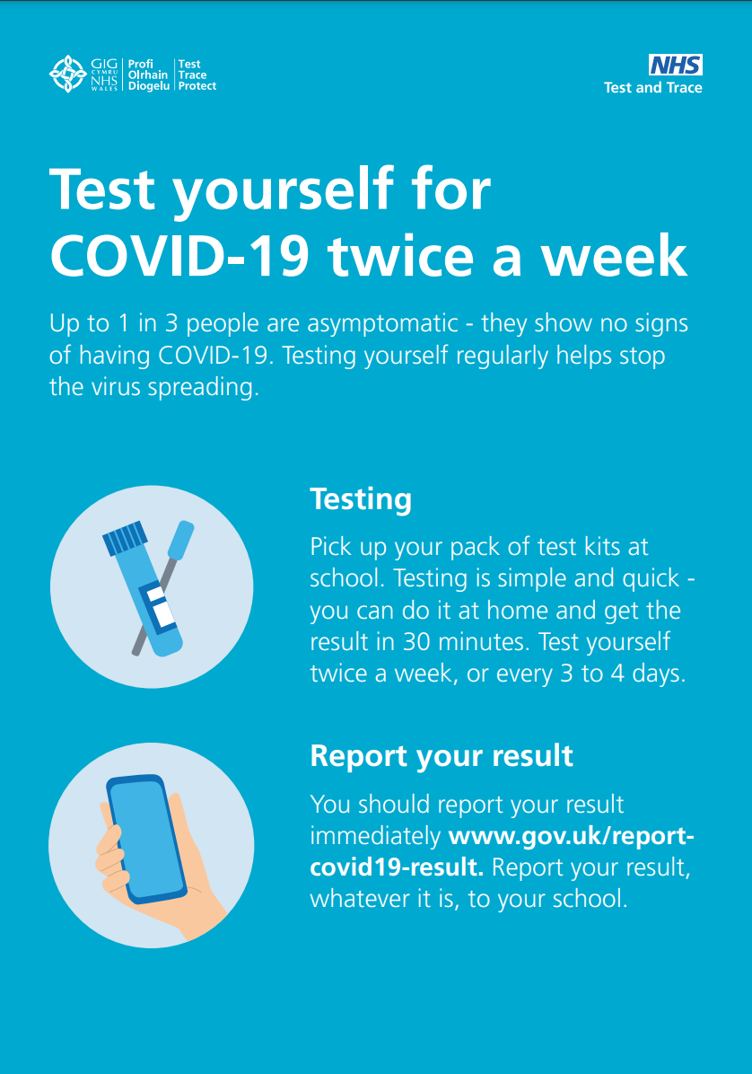

Staff Guidance for

Covid-19 Self-Testing

Dear Staff Member,
The Department for Education has recently announced that it will start a programme of asymptomatic Covid-19 testing in primary schools, school-based nurseries and maintained nursery schools.
Along with the other protective measures we are taking, testing will allow us to take further measures to help you and other staff members to work in as safe an environment as possible. Up to one in three people who have Covid-19 have the virus without symptoms so could be transmitting the virus unknowingly. Tackling the pandemic requires identifying asymptomatic, infectious individuals. By testing, we will help to reduce the spread in our school and community and I am therefore grateful to all staff willing to take the tests.
Lateral Flow Device (LFD) tests have been widely and successfully used to detect COVID-19 in asymptomatic individuals. No test is perfect, but the speed and convenience of LFD tests supports detection of the virus in asymptomatic individuals who would not otherwise be tested. They are clinically approved and are crucial in the fight against the virus. As the tests are more sensitive with higher viral loads, there is a risk of returning a negative result when viral loads are low (e.g. in the early stages of infection). This is why Public Health England recommend two LFD tests 3 to 4 days apart, or regular testing, to enhance detection by picking up any cases which were not detected during the first test and to catch any new infections.
If you test positive using a LFD, it is likely that you are infectious at that moment, whereas people testing positive on a polymerase chain reaction (PCR) or lab-processed test could be in the less infectious early or late stages of disease. This means that by using the lateral flow test we can identify people with a high viral load who are the most likely to spread the virus further. A negative LFD result must not be read as a means to relax or ignore social distancing or other virus prevention measures intended to reduce transmission – LFD is an additional tool that contributes to reducing risk.
Staff who are attending school will need to take the tests every week on a Sunday and Wednesday. In our school our first test will take place on Wednesday 27th January 2021. These will need to be done and reported by 9 p.m.
Staff attending school will be conducting these tests at home, twice a week and can collect tests from their test Co-ordinator (ND) on Monday 25th January 2021.
An initial introduction into how the tests work:
Staff will be able to collect from school LFD test kits which enable self-testing from home. Tests are free of charge and will be provided by the school. Staff will conduct the test, before coming into work, twice a week. In our school, we are asking that all staff do this on Sunday evening and Wednesday evening with their result submitted by 9.00p.m via email to testresults@st-andrews.lincs.sch.uk . This is because we will then be able to organise any necessary cover or bubble closures in good time. The LFDs supplied do not require laboratory processing and can provide a quick result in around 30 minutes. Comprehensive guidance on self-testing is contained in this document and you will also receive a copy of instructions with your first collection of test kits. Please do not follow the instructions contained within your test kit as this has since been changed since distribution by Test and Trace.

There is also a useful video to show you how to administer the test. Press ctrl and click the image below to view the video on how to do a Covid-19 self-test
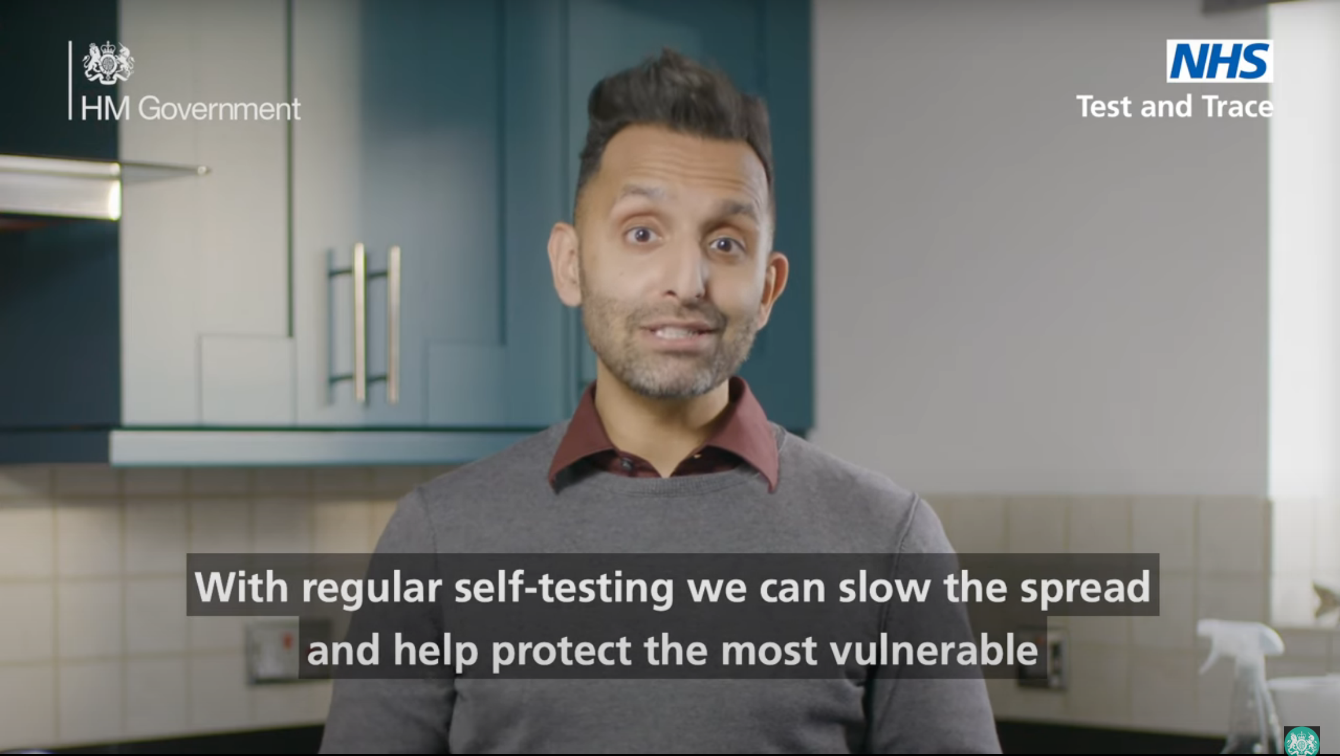
A more detailed step-by-step guide in written form can be viewed by clicking here.
Reporting your Result:
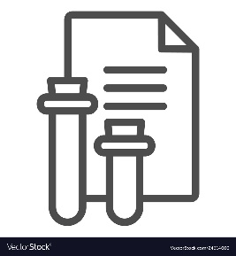
Once the test has been conducted you must:
- Log the test result online with Test and Trace by clicking here.
- Separately inform school of the test result – there will be a register in the entranceway for you to complete each day you test, however if you test positive you must email testresults@st-andrews.lincs.sch.uk .
You will also receive a text or e-mail notification of a positive or negative result from NHS Test & Trace.
Consent / Privacy / Reporting a Result:
Once you understand the testing process and read the privacy notice that is available on the school website , if you choose to participate, you are committing to self-administer the test and provide your results. You must ensure that you provide your results (positive, negative or void) to NHS Test and Trace via the self-report gov.uk page. Staff who decline to participate can still attend school if not symptomatic.
People who decline to participate in this testing programme should follow the usual national guidelines on self-isolation and anyone should get tested if they show symptoms.
As with all stages of this pandemic, I will continue to do my utmost to support your well-being at this time. Please do not hesitate to ask if you have any questions or click here for frequently asked questions.
Best wishes,

Mr D W Hodgson
Headteacher
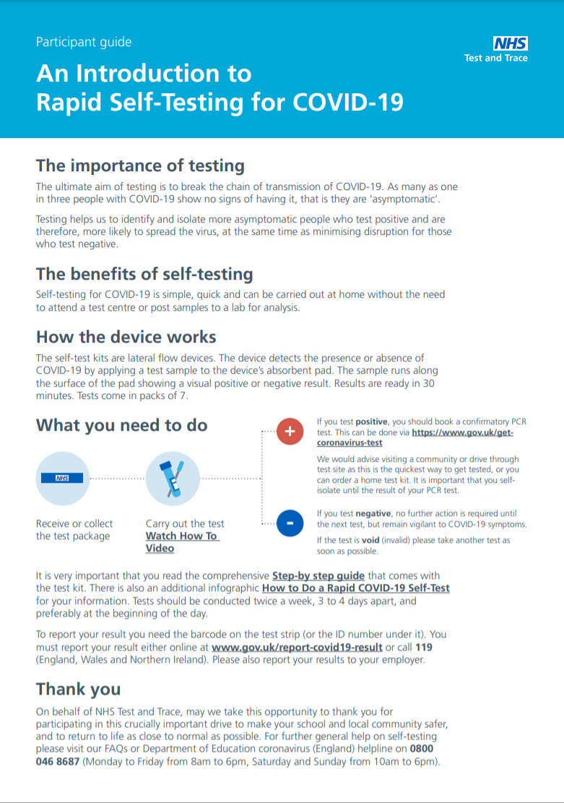
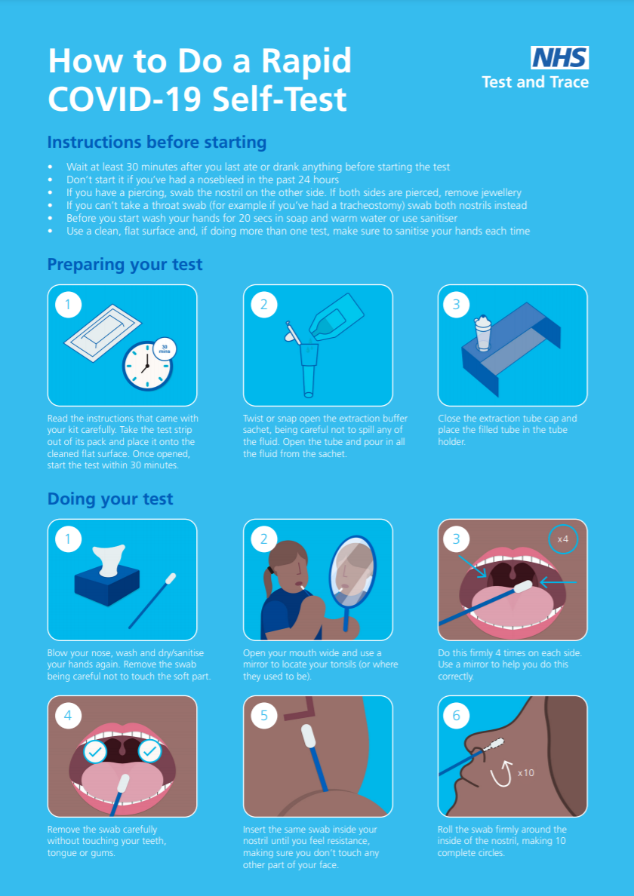

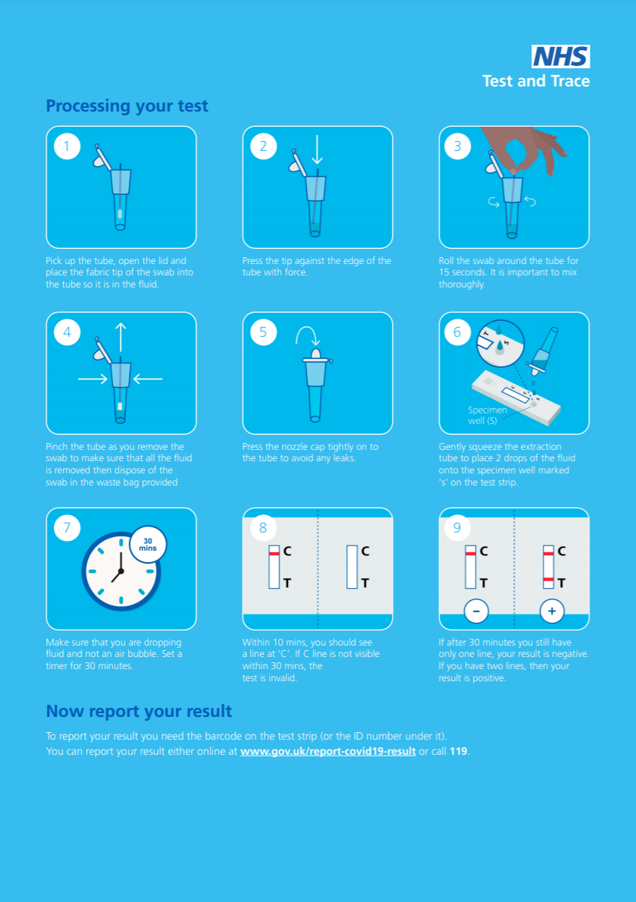
Don’t forget, you also need to report your result to the school. If your test indicates a positive result, you must
Email testresults@st-andrews.lincs.sch.uk

