New Registration Process for Music Lessons
Dear Parent / Guardian,
Thank you for considering Lincolnshire Music Service (LMS) for instrumental tuition!
LMS, which is the lead organisation for the Lincolnshire Music Education Hub, is delighted to provide you access to high quality instrumental tuition. LMS received the 2019 Music Education Council Major Prize in recognition of their quality offer and outstanding leadership and innovation.
Would you like Instrumental lessons for 2020/21?
COVID19 has resulted in new ways of working for LMS in order to shape how we deliver tuition. We're working closely with each school and will be able to provide tuition which will be either face to face, virtual (LMS DigiTeach) or a combination of both. It is for this reason that only individual tuition is available during Autumn 2020. We hope to lift this restriction in due course. The following lesson types are available on a range of instruments as well as voice:
Lesson Type | Cost per lesson*
Individual 15 minute | £9.20
Individual 20 minute | £12.26
Individual 30 minute | £18.40
*Subsidised lessons are offered to pupils eligible for free school meals (50%) and Looked After Children (100%)
Instrument Hire is also available on all instruments priced at flat-rate fee £17.50 per term (Autumn, Spring and Summer).
We would like to build stronger partnerships direct with parents/guardians, and will be introducing, from September 2020, a new platform for booking and managing tuition called Speed Admin. This will give you direct access to your individual lesson schedules, teacher details, missed lessons, and the ability to view the digital study-plan between tutor and pupil. You can also view lesson details on the SpeedAdmin App – very handy to have on the go!
More information and complete Terms and Conditions can be found on the LMS website https://www.lincsmusicservice.org/instrumentallessons
How to register for instrumental tuition?
In order to book instrumental tuition, the parent or guardian will now register directly with Speed Admin here:
https://uklincsmusicservice.speedadmin.dk/registration#/

Follow the link and register the student by:
- Selecting the school the pupil attends
- Selecting the instrument you would like them to learn
- Select the duration of the lesson required
- Select Instrument Hire if necessary
- Apply for a tuition voucher if the pupil is eligible to subsidised lessons
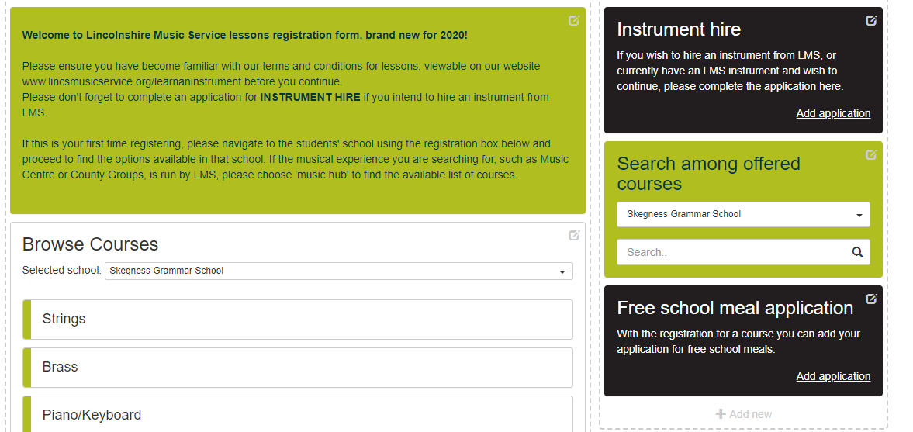
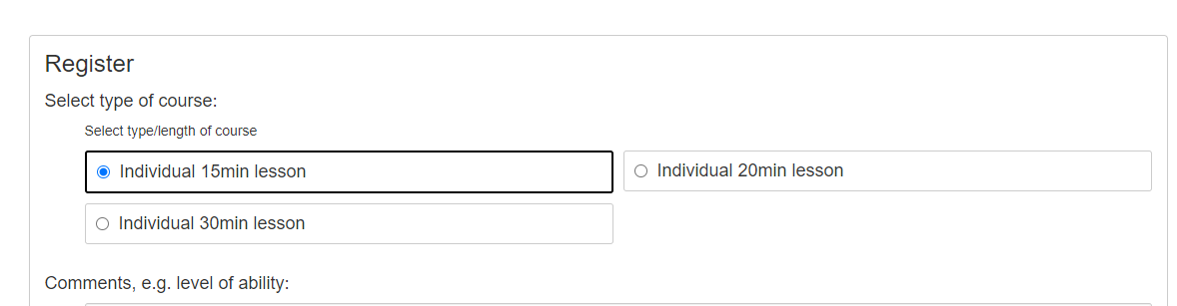
Once you have registered, the pupil will be assigned an available tutor by LMS and the parent/carer notified of the relevant details via email.
How do I pay for the lessons?
Charges for lessons will be invoiced three times a year (Autumn, Spring and Summer) direct to the parent / guardian.
Payment for each term of tuition is required at least 1 week before lessons are scheduled to start. We're also working to offer a payment plan facility via the LCC card payment portal which will make the payment and management of lessons even more flexible. Watch this space!
We realise this is a new and exciting way of working, however may be unsettling for some of you. For any further questions or guidance please contact musicservice@lincolnshire.gov.uk and we'll be happy to guide you through the process!
Yours sincerely
Lincolnshire Music Service
Website: www.lincsmusicservice.org
Twitter: www.twitter.com/LMSlincsmusic
Facebook: www.facebook.com/lincsmusicservice
Instagram: https://www.instagram.com/lincsmusic

