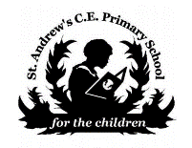
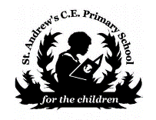
Geography at St. Andrew’s C of E Leasingham

INTENT | IMPLEMENTATION | IMPACT
Our Geography curriculum begins with a study of OUR local area and progresses on to explore the wider world, its people, places and the environment.  Children need to have knowledge of the world – its cities, countries, continents, seas and oceans with an understanding of human impact on ecosystems.  Our geography curriculum is designed to develop pupils’ curiosity and fascination about the world encouraging them to ask questions of things beyond their lived experience.  Lesson outcomes ensure delivery of robust geographical knowledge, confident enquiry skills, the ability to interpret a range of maps, collect and analyse data and to communicate findings in both written and oral form. | Geography is taught through our weekly Topic lessons Units are chosen to ensure coverage of EYFS, KS1, LKS2 AND UKS2 national curriculum requirements with a balance of history and geography. The Geography curriculum will be taught in response to questions which are aimed to be challenging, inspiring, creative, nurturing and encourage active learning.  The learners will revisit geographical skills and knowledge in order to embed and deepen understanding.  The lessons are carefully planned to ensure that all children are well supported in response to their own learning. We ensure that trips and visitors enhance the learning experiences for the children. | The impact of our geography curriculum is that our learners are equipped with the geographical skills and knowledge that will enable them to be ready for the secondary curriculum and for life as an adult in the wider world.  The children will be able to discuss their learning and demonstrate their knowledge and understanding through a range of activities.  The children’s learning is assessed against the age-Related expectations that are based on the 2014 National Curriculum statements for Geography and linked to our Schools Skills Progression documents. .

