Book ideas/ expectations/ non-negotiables/ active ingredients (Y1-Y6)
The journey of writing seen in books should include:
- Experiences to gain knowledge and vocabulary
- Finding the Shape/deconstruction
- Sentence Stacking lessons/ modelling plot points/ NF shapes
- Independent sequence (additional experience days may be required to support knowledge, plot and vocabulary ready for the independent stage)
If there is a particular weakness in grammar and/or punctuation, this can be included within the journey. If it is included, this must then be part of the success criteria during the independent sequence.
The display outside the Y6 classroom shows additional examples of the journey for writing
If you are planning your own unit of work, please ensure that the above expectations are followed. Some designed units may be able to have the sentence stack lessons omitted if the desired success criteria have been modelled in previous units, so the children can draw on from that knowledge. The Writing Rainbow, lenses, NF shapes and vocabulary gathering/development, however, need to be embedded within the writing journey to ensure consistency and coherence. Please speak to the subject leader if you are unsure about anything.

Experience lessons:
These do not need to be evidenced if the children do not need to refer back to it.
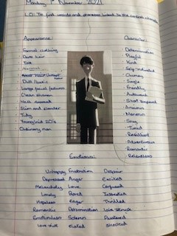
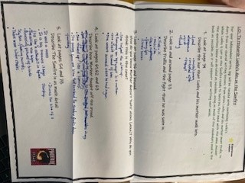

Finding the Shape lessons (deconstruction)
Again, not needed to be evidenced in KS1 if a ‘Finding the Shape’ activity is practical and displayed somewhere for the children to refer to.
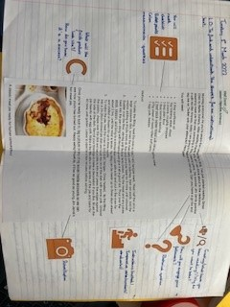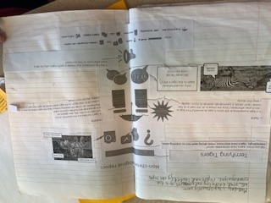#
Sentence Stacking lessons
- Two sides – thinking side/writing side
- Steps to Success with pictures of lenses to be put at top of writing side
- Thinking side to be in a grid – 3 rows for 3 learning chunks and each row split as needed – key for vocabulary gathering. At beginning of Year 1 vocabulary will be given, all other year groups children should be writing their own ideas (SEN could be scribed)
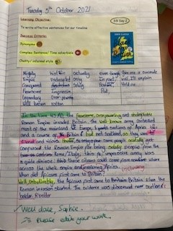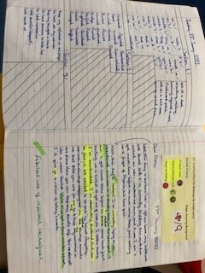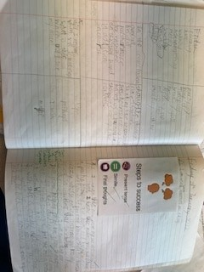

Independent sequence
This sequence should follow the below journey (each point is not a specific lesson):
- Discuss the purpose/ key features of desired outcome
- Agree/recap success criteria from sentence stack lessons
- Experiences to support knowledge and vocabulary
- Planning
- Editing (if ready)
- Writing for published piece (not compulsory)
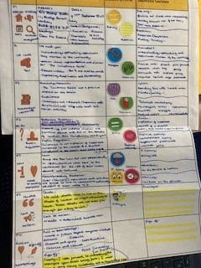
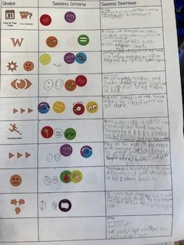
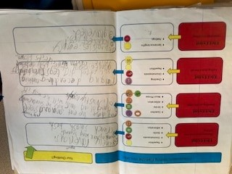
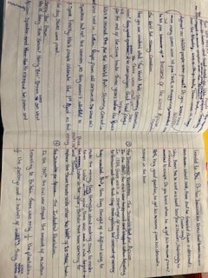
- Self-assess (LJs for KS2 when ready)

Feedback
- During sentence stack lessons, marking should be addressing the key non-negotiable spelling, punctuation and grammar, as the lessons are highly scaffolded.
- The learning objective/ success criteria to be highlighted in green show if it has been achieved as well as the words/phrases in written work where objective has been achieved.
- Verbal feedback is always preferable and any teacher corrections with children can be shown in green pen. If marking is done away from children, a pink highlighter to be used to show children where to edit/consider their next steps.
- If children self or peer assess their work they are to mark as above with yellow highlighter.
- Longer extended pieces of writing/independent writing would require more detailed oral/written feedback and completion of school monitoring form for each child twice a term.
- Work edited by the children will be done in purple pen.

Displays/ Learning environment
Within the classroom, the following, where feasible, are displayed and referred to:
- The Writing Rainbow (clear and accessible for the children)
- The Writing Rainbow lenses
- The non-negotiable laundry
- The journey (either plot points or NF shapes to show the journey of writing.
- Sentence stack area (to celebrate the children’s sentences)
- Where feasible, an area for live modelling.
- Resources to support independent writing (word mats, spelling mats, dictionaries, thesauruses etc)

