St Andrews Leasingham

An Introduction to Microsoft Teams for Parents/Guardians

Accessing Microsoft Teams
Microsoft Teams requires your child to log in (this ensures all data is kept personal and secure). This is always done using their school login, whether using an internet browser such as Chrome/Edge/Safari or accessing directly via the Microsoft Teams app..

Accessing via a web browser:
On a new tab, browse to the Teams website by typing the following URL into a web browser;
https://teams.microsoft.com

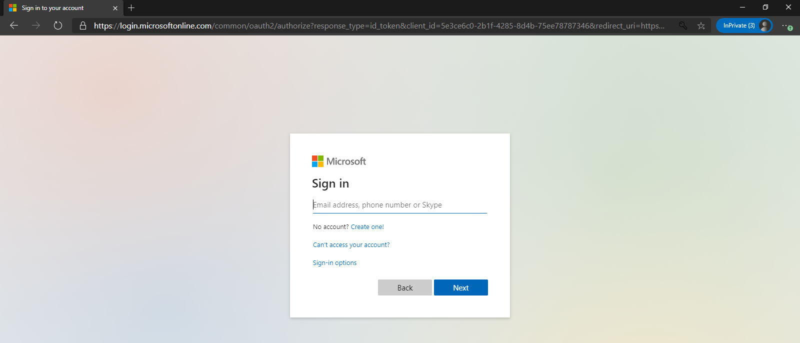

Your child should then login with their school username and password. Once logged in you will be taken through to your child’s Teams site. (It should look something like this)

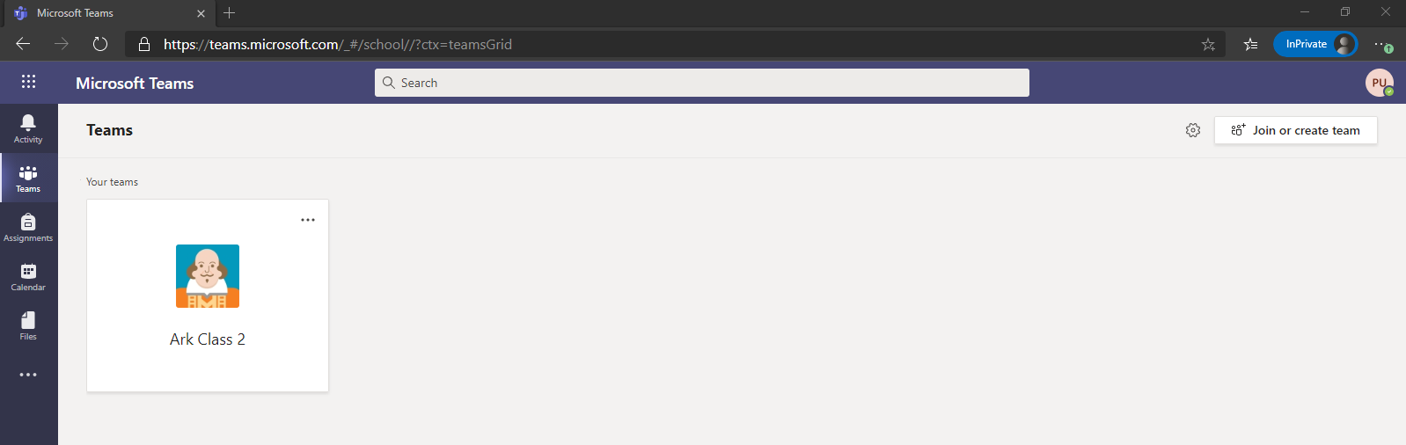

Accessing directly via the Microsoft Teams app:

Microsoft Teams is also available as a free download from the app store on most Apple and
Android devices and can be downloaded onto both tablets and mobile phones. Search for ‘Microsoft Teams’ on your regular app store and then download directly from here. Please note, that the experience of Teams is better suited to a laptop and using a phone may have limited features due to the smaller screen size.
Using Microsoft Teams
Once your child has logged into Microsoft Teams, they should be able to see a screen similar to the one below, with any classes they are part of appearing in the ‘Teams’ section.

*Please note that this will look slightly different depending on whether your child is accessing from a web browser (as above) or directly via the app (the menus or tabs appear down the left-hand side on a web browser, but along the bottom of the screen on the app), however the ‘labels’ should remain the same.
Once in a Class Team, there may be different channels which allows the teachers to organise information on different topics/themes. These will be shown underneath the name of the Team, as shown in the picture below:
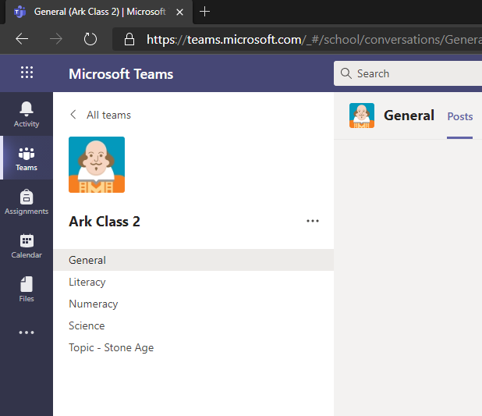
Along the top of the Team, you will see different tabs, namely ‘Posts’, ‘Files’, ‘Class Notebook’, ‘Assignments’ as shown in the picture below. These are where you can access different features within the Team.

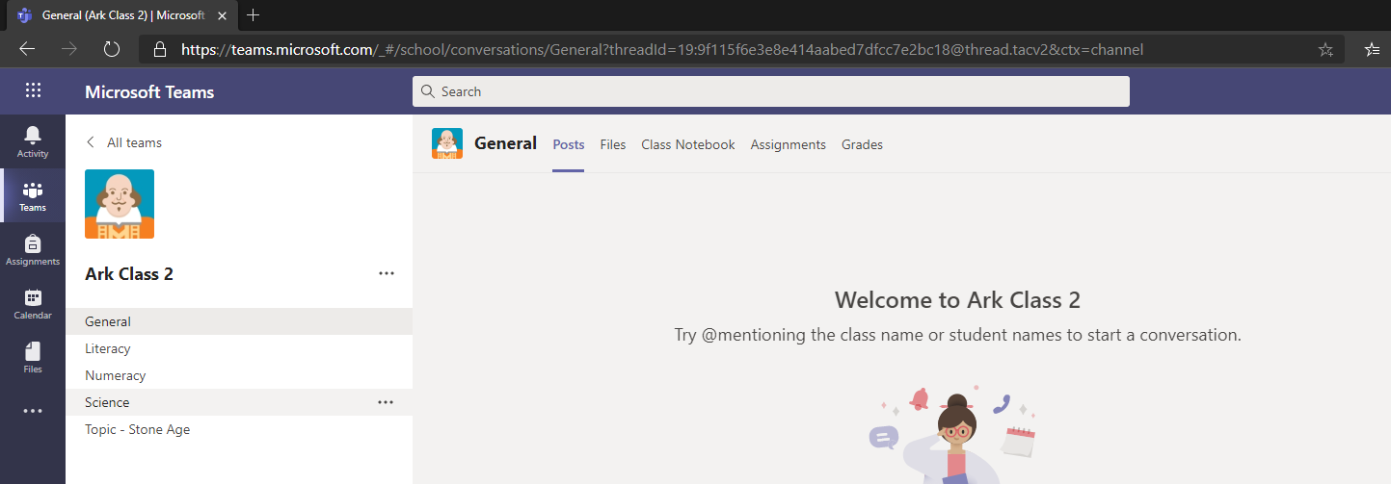

- ‘Posts’ is where general conversations regarding classwork/home learning can take place. Pupils can post a comment and can also reply to others’ comments and questions. You can also upload/attach files, pictures, and documents into a post.
- ‘Files’ is where your child can access Word documents, PowerPoints etc. saved by their teacher (as shown in the picture below). Files may be organised into different folders – simply click the folder to access the files within. Pupils can open a file by clicking on its name. They can also collaborate on a document – all changes made can be seen by everyone who is a member of the team – great for working together on a project or sharing questions.
- ‘Class Notebook’ is like a book, where each pupil has their own chapter and then all their work is done on new pages of their chapter. Pupils can only see a shared class chapter and their own chapter, but teachers can see them all.
- ‘Assignments’ is where your child will find specific assignment tasks that have been set for the class. This could be something as simple as answering a set of multiple-choice questions to writing an essay on a specific subject.
- The ‘+’ icon is where your child can access other Microsoft apps (i.e. Word, PowerPoint) and where your child’s class teacher may save frequently used websites.

This covers the main features we will be using Microsoft Teams for. We would remind pupils of our usual online safety rules and responsibilities which should be followed at all times when using Microsoft Teams – i.e. being mindful of others’ thoughts and feelings, only posting comments and questions relating to classwork and home learning.

